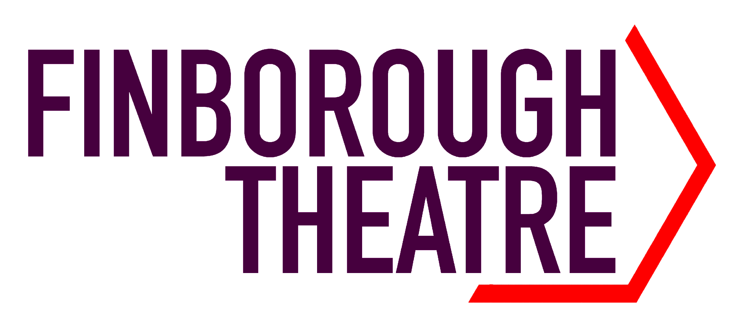
November 2023 – February 2024 season at the Finborough Theatre
The world premiere
JAB
by James McDermott.
Directed by Scott Le Crass.
Presented by Free Run Productions in association with Neil McPherson for the Finborough Theatre .
Supported by Sue Pomroy of SJP Management.
Cast: Kacey Ainsworth. Liam Tobin.
“Last twenty nine years. You haven’t had to make any decisions. I’ve paid every bill, made every sacrifice… But now… You made a choice. You’re gonna have to face the consequence”.
The world premiere of Jab opens at the Finborough Theatre for a four week limited season on Tuesday, 20 February 2024 (Press Nights: Thursday, 22 February 2024 and Friday, 23 February 2024 at 7.30pm).

Anne is tired. Tired of menopause. Tired of working in a dying NHS. And tired of her lazy sexist Daily Mail reading husband Don. But they’ve been together twenty nine years. They know each other inside out. They’ve survived so much.
Then COVID plunges the country into lockdown, forcing them to isolate together. After all, the home is a place of safety… isn’t it?
As the world falls apart outside, Anne and Don’s marriage slowly falls apart inside. But soon there will be a solution. Won't there?
Inspired by true events, Jab is a coruscating new black comedy, exploring power, gender, domestic violence, conspiracy theories, ignorance, and the limits of love.

Kacey Ainsworth and Liam Tobin star in this stunning new British play, directed by Scott Le Crass, recently nominated for Best Creative West End Debut at The Stage Awards for his production of Rose, starring Maureen Lipman.

Playwright James McDermott productions include Time and Tide, nominated for an OffWestEnd Award for Best New Play and long-listed for the Bruntwood Prize (Park Theatre and East of England Tour) and Rubber Ring (Pleasance London and UK Tour). Both plays are published by Samuel French. Their other plays include Acid’s Reign (Vault Festival) and The Birds and The Bees (New Wolsey Theatre, Ipswich, and East of England Tour). James’s poetry collections include Wild Life (Nine Arches Press), Erased (Polari Press) and Manatomy which was long-listed for Polari’s First Book Prize (Burning Eye Books). James has written plays for BBC Radio 4, and is one of the writers on EastEnders. They teach scriptwriting for the National Theatre and Arvon, and also lecture in creative writing at the University of East Anglia.

Director Scott Le Crass directed the revival of Martin Sherman's Rose, starring Maureen Lipman, which was streamed online in 2020, screened on Sky Arts in 2021, and in 2022 it was presented onstage at Hope Mill Theatre, Manchester, and Park Theatre where it won an OffWestEnd Award for Best Solo Performance. In 2023, Rose transferred to the West End, and Scott has been shortlisted for Best Creative West End Debut at The Stage Awards. He was nominated for both OffWestEnd and Broadway World Awards for Best Director for Rose. Scott is just about to direct Toxic by Nathaniel Hall at HOME, Manchester.

Acclaim for playwright James McDermott
"Catch it if you can. So moving, funny, truthful and compelling. Beautifully performed by a wonderful cast of actors" Stephen Fry on Time and Tide
“Bold, graphic, startling” Julian Clary on Manatomy
“Hilarious and honest” Jonathan Harvey on Manatomy
★★★★★ "One of the best pieces of new writing I have seen in the last few years.” Pocket Size Theatre on Time and Tide
★★★★ “A humorous and moving portrayal of trapped lives…peppered with brilliant one liners and moments of poetic excellence" Theatre News on Time and Tide
★★★★ “Touching, truthful, funny.” The Reviews Hub on Time and Tide
★★★★ "A small, detailed and touching play, it astutely balances its humour with moments of tension and quiet revelation" Unrestricted Theatre on Time and Tide
★★★★ "It’s always good to see a new talent emerging and in James McDermott that is clearly and pleasingly what we have” Sardines Magazine

The press on director Scott Le Crass
★★★★★ “A directorial triumph for Scott Le Crass.” Broadway Baby on Rose.
★★★★★ “Director Scott Le Crass recognises the need for simplicity and understatement.” WhatsOnStage on Rose.
★★★★★ “Speaking of direction, this is a masterclass.” All That Dazzles on Country Music.
★★★★ “Scott Le Crass’ directorial style matches Stephens’ unfussy writing. It’s quietly confident, never unnecessarily showy, and infused with a sense of Le Crass’ evident love for the play.” The Stage on Country Music.

PRESS NIGHTS: THURSDAY, 22 FEBRUARY 2024 AND FRIDAY, 23 FEBRUARY 2024 AT 7.30PM
PHOTOCALL: TUESDAY, 20 FEBRUARY 2024 AT 1.00PM–1.30PM

Covid Safe – Masks are mandatory at all Sunday matinee performances.

Finborough Theatre, 118 Finborough Road, London SW10 9ED
Book online at www.finboroughtheatre.co.uk
Box Office 020 7244 7439
No booking fees
Tuesday, 20 February – Saturday, 16 March 2024
Tuesday to Saturday evenings at 7.30pm. Saturday and Sunday matinees at 3.00pm.
Prices until 3 March 2024 – Tickets £20, £18 concessions, except Tuesday evenings £18 all seats, and Friday and Saturday evenings £20 all seats. Previews (20 and 21 February) £15 all seats.
£10 tickets for Under 30s for performances from Tuesday to Sunday of the first week when booked online only.
£15 tickets for residents of the Royal Borough of Kensington and Chelsea and the London Borough of Hammersmith and Fulham on Saturday, 24 February 2024 at 7.30pm when booked online only.
Prices from 5 March 2024 – Tickets £23, £20 concessions, except Tuesday evenings £20 all seats, and Friday and Saturday evenings £23 all seats.
Group Bookings for all performances – 1 free ticket in every 10 purchased.
Performance Length: Approximately 75 minutes with no interval.

For more information, interviews and images, please contact
Ellie Renfrew on e-mail press@finboroughtheatre.co.uk or 07384 379624
Download press releases and images at http://www.finboroughtheatre.co.uk/press-resources.php

